
Name:

11 Physics
Motion and Forces
Topic Test 2015

Score: _________ / 64 ______________%

TIME ALLOWED FOR THIS TEST
Working time for this paper: 65 minutes

MATERIAL REQUIRED OR RECOMMENDED FOR THIS TEST

This question and answer booklet
2015 Physics Formula & Constants Sheet
Pens, pencils, eraser, rule, Mathaid or Math-o-Matt
Scientific calculator

INSTRUCTIONS
Answer all questions and write answers in the spaces provided.
Numerical answers should be evaluated with three significant figures unless otherwise stated and given in scientific notation.

1. A motorbike, which is travelling at a 10.0 ms⁻¹ along a straight road, accelerates at 2.00 ms⁻² for 10.0 s. It maintains this velocity for 15.0 s before braking uniformly for 5.00 s to reduce speed to 15.0 ms⁻¹. The motorbike continues at this velocity along the road.

(a) Draw a velocity-time graph for the motion described. The time scale needs to run to at least 40.0 s. The scales need to be drawn accurately.

(4)

(b) Determine the deceleration experienced by the rider whilst reducing speed.

(3)

(c) How far has the rider travelled after 40.0 s?

(4)

2. A hot air balloon in central Australia is rising at a constant speed of 7.00 ms⁻¹ at a height of 1.50 x 10² m above the ground. At this point a passenger accidentally released a sand bag on the outside of the basket and it falls to the ground.

(a) Does the bag start to fall towards the ground immediately it is released, or does it continue to move upwards initially? Explain your answer briefly.

(2)

(b) Calculate the velocity of the bag at impact with the ground.

(3)

(c) How long does it take for the bag to reach the ground?

(3)
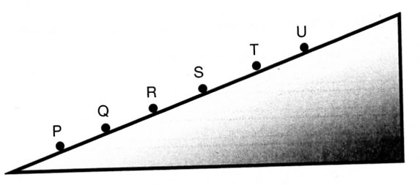
3. A group of students performed an experiment to investigate the acceleration of marbles down a slope. The data collected is shown in the table below.

For an object starting from rest, the relationship between the distance (d) moved down the slope and time is given by:
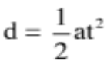

(a) Manipulate the data so that you will be able to generate a straight-line graph. A spare column has been provided in the table.
Starting Position | Distance rolled (m) | Average Time to Roll (s)
P | 0.5 | 0.55
Q | 1.0 | 0.82
R | 1.5 | 1.00
S | 2.0 | 1.21
T | 2.5 | 1.30
U | 3.0 | 1.38
(2)

(b) Graph the data on the grid provided on the next page and draw a line of best fit.
(3)

(c) Use the graph to determine the acceleration experienced on this slope.

(3)

4. A workman in a Bunning's warehouse is using a large trolley to shift a pallet of tool boxes with a mass of 1.10 x 10³ kg. The trolley uses multi-directional wheels to make movement easier.

In trying to start the trolley moving, the worker struggles very hard. He manages to get it moving and finds he doesn't have to pull very much to keep it moving. He then tries to change the direction of the trolley to turn left 90°, and again struggles tremendously to control the trolley. Explain why these things occur.

(4)

5. An iron ore train is being assembled in Port Hedland, ready to be sent to pick up ore from
Tom Price. Two engines of combined mass 5.10 x 10⁵ kg moving at 1.00 ms⁻¹ shunt and join with 10 empty ore cars, each of mass 2.40 x 10³ kg.

(a) Calculate the speed of the combination immediately after the impact.

(4)

(b) Is mechanical energy conserved in this collision? Justify your answer by calculation.

(3)

6. In the game of Australian Rules football, the central umpire starts the game by bouncing
the 464 g ball on a bounce pad in the middle of the oval. An umpire throws the ball down at 8.00 ms⁻¹ and it rebounds at 11.0 ms⁻¹ after being in contact with the pad for 0.115 s.

(a) What is the change in momentum of the ball?

(4)

(b) Calculate the impulsive force that acted during the time of impact.

(3)

(c) Umpires find it very difficult to bounce the ball high enough if they have to do so on the softer grass around the playing area. Using your knowledge of Physics' principles, explain why this is so.

(3)
7. An electric motor rated at 4.90 x 10⁵ W is used to pull a roller coaster of total mass 6.70 x 10³
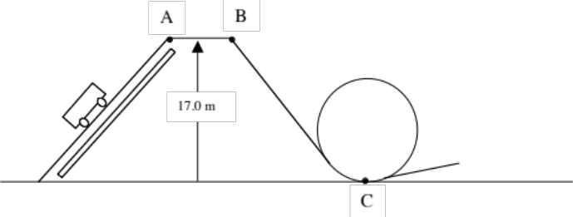
kg up to a height of 17.0 m as shown in the diagram. At point A, the coaster has a speed of 1.50 ms⁻¹, which it maintains to point B.

(a) Calculate the total energy of the roller coaster at point A.

(4)

(b) Theoretically, how long would it take the motor to lift the roller coaster up to point A?

(2)

(c) If the coaster then rolls down to point C, what would be its speed?

(3)

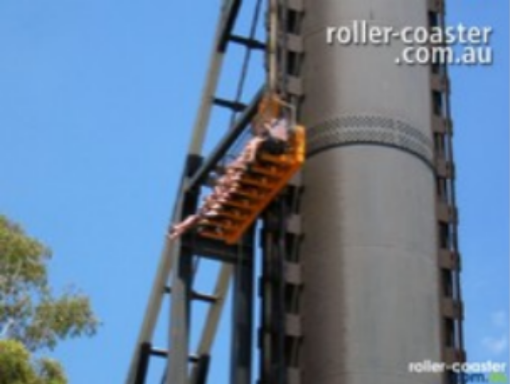
8. At Dream World on the Gold Coast, the Giant Drop carries groups of 8 people to a height of 1.20 x 10² m before allowing them to 'free fall" to 20.0 m before decelerating them. Assume the combined mass of the 8 people and the bench they sit on is 8.00 x10² kg.

(a) Calculate the force required from the
internal lift mechanism to move the people upwards at a constant speed.

(3)

(b) If the deceleration at the bottom of the ride is equivalent to "3.60 g" (3.60 times the acceleration due to gravity), determine the force exerted by the internal mechanism.

(3)

END OF TEST ☺

